Bed-side Diagnosis of Gall-Bladder stones, even clinically silent
The diagnosis of stones in the cholecyst is frequently difficult at the
bed-side, due to the fact that the clinical phenomenology is not easy to be
correctly interpreted or completely absent. Obviously, more difficult is recognizing both silent stones, i.e. without any clinical symptomatology, and diseases with light, not severe, symptomatology, wich are actually very frequent.
In the following, aredescribed briefly simple signs, reliable in prompt recognizing this sometime dangerous cholecyst disease with the aid of auscultatory percussion or more
precisely said, of Biophysical Semeiotics (1-3).
In order to performe the diagnose, doctor has to know, at least, the
auscultatory percussion of the stomach (Fig.1)
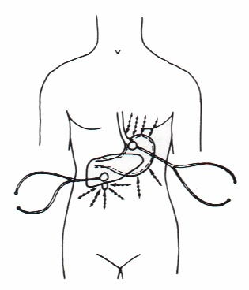

Fig. 1
The knowledge of the auscultatory percussion of liver and gall-bladder, of course,
highlights and enriches method enforcement (1).
In healty individuals digital pressure, applied upon the skin projection area of
gall-bladder,i.e. right superior abdominal quadrant, provokes the so-called
"gastric aspecific reflex" (= in the stomach, fundus and body dilate; on the
contrary, antral-pyloric region contracts), as clearly indicated in Fig 1, after latency
time of 8 sec. exactly: intensity < 2 cm.. Physiologically, the reflex persists
identical for at least 5-10 sec.and than disappears.
Interestingly, in case of gall-bladder stone(s), even clinically silent, the latency time is shorter (3-4sec.), intensity is 2 cm. or more (in relation to disorder entity) and, soon
thereafter, characteristically its intensity diminishes of 1/3 : "lythiasic
reflex", observed also in case of other stones and calcium deposition, localized
in whatever biological system, including kidneys and arterial wall.
Really, if patient performs the Valsalva's manouvre, the reflex appears
spontaneously in the same manner, described above.
This evaluation is, however,less specific than the first one. Moreover, the"cholecyst preconditioning" (2)provides usefull data: after an interruption of 5 sec.doctor carries
out a second ( and third) evaluation. In normal subjects the latency time turns
out lenghtened (10-12 sec.). On the contrary, in cholelythiasis the latency time
of gastric aspecific reflex is identical (3-4 sec.) or more frequently shorter,
in relation to disease seriousness.
The physio-pathology of the biophysical-semeiotic signs is based upon
microvascular conditions of the gall-bladder wall. Further interesting signs of gall-bladder stones are fully described elsewehre (1-3) as the cholelithyasic constitution.
Due to reader’s knowledge of Biophysical Semeiotics unfortunately clinical miroangiological signs are at the moment overlooked.
1. Stagnaro S., Stagnaro-Neri M., Diagnosi percusso-ascoltatoria dei
calcoli biliari silenti. 6 ° Incontro Segusino di Medicina e Chirurgia. Susa 19
Maggio, 1990. Atti, pg. 79. Ed. Minerva Medica, Torino.1990
2. Stagnaro-Neri M., Stagnaro S., Deterministic Chaos,
Preconditioning and Myocardial Oxygenation evaluated clinically with the aid of
Biophysical Semeiotics in the Diagnosis of ischaemic Heart Disease even silent.
Acta Med. Medit. 13, 109,1997
3. Stagnaro-Neri M., Stagnaro S., La "Costituzione Colelitiasica":
ICAEM-a, Sindrome di Reaven variante e Ipotonia-Ipocinesia delle vie biliari.
Atti. XII Settim. It. Dietol. 20, 239, 1993
4. Stagnaro-Neri M., Stagnaro S., La sindrome dispeptica funzionale
da discinesia delle vie biliari. Diagnosi percusso-ascoltatoria. Cin. Ter. 127,
363, 1988

